10353 Marble Mountain Road, Orangedale- Floor Plans (not to scale)
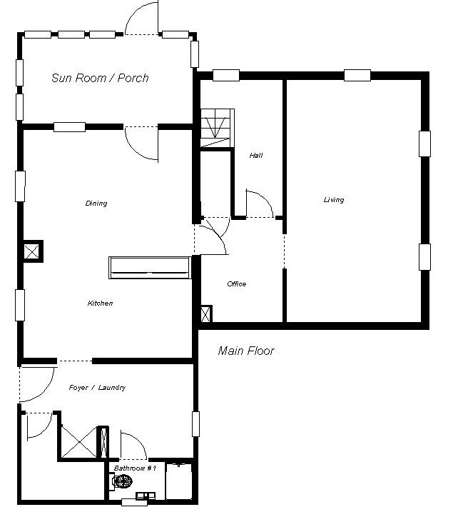
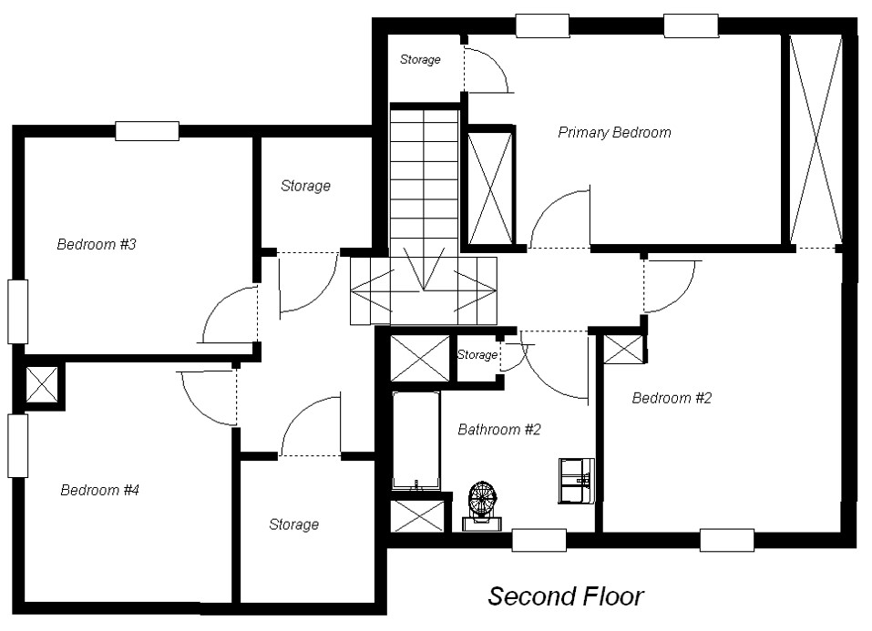
Second Floor
not to scale

